**About the Data Center Flexibility Initiative**

The mission of the Data Center Flexibility Initiative (“DCFI”) is to facilitate a more active and collaborative approach between project development and utility system planning, leveraging the untapped energy flexibility that data centers can offer now and over time. These efforts will lead to more sustainable deployment of digital infrastructure in a manner that will support utility system planners at a critical moment in building the next generation of industrial demand domestically.

DCFI was formed in response to opportunities identified at the “[Future of Data Centers Summit: Defining The Path Forward For Data Center Innovation, Energy Management, & Sustainability](https://sidewalkinfra.com/news/data-centers-are-at-a-crossroads-between-ai-and-sustainability).” This event, hosted by Sidewalk Infrastructure Partners (“SIP”) in June 2023, brought together dozens of leaders across energy, policy, academia, and technology.

This position paper builds on those discussions and is authored by SIP with the support of reviewers and collaborators from across the data center and energy ecosystems. The paper is intended to raise awareness and to serve as the first step towards workshops, publications, and other collaborative efforts to further develop and implement the concepts discussed in this paper. DCFI invites interested stakeholders to learn more by visiting [datacenterflexibility.com] or emailing [connect@datacenterflexibility.com].

SIP is a holding company that builds innovative technology-enabled infrastructure companies and projects that deliver positive social and environmental impact in partnership with the public sector. Its mission is to make infrastructure more efficient, sustainable, and inclusive, rooted in the belief that technology will help to solve some of the world’s most pressing social and environmental challenges.

**Acknowledgements**

While the ideas and principles outlined in this report incorporate the perspectives of hundreds of conversations across several industries, SIP would especially like to thank several contributors who lent their time and expertise into reviewing this position paper, including: []

Contributors were not asked to endorse this paper, nor are they responsible for any errors or omissions contained herein. All views and opinions expressed are those of SIP only and do not necessarily reflect the views and opinions of the contributors or their affiliates, employees, or investors.

**Executive Summary**

Utilities are facing an inflection point in managing a near-term surge in the demand for large-scale industrial loads, such as data centers and onshoring manufacturing, as well as broader electrification initiatives including electric vehicles. At the same time, these same utilities are undergoing transitions to more intermittent renewable energy sources over the next decade and beyond.

Today’s development practices have put utilities in a bind between accommodating these large load requests and continuing to reliably and affordably provide power to their customers. These challenges have led to a re-evaluation of interconnection practices for these large loads. The near-term solution has been pushing power delivery dates far into the future. However, at a macro level, not building these projects domestically in the near-term is not sustainable and has significant economic development, innovation, and national security implications, and thus the industry must coalesce around new engagement strategies for these large loads.

Data centers, expected to eclipse $100 billion of annual capex spend to bring online approximately 40,000 megawatts (“MWs”) of new capacity requirements by 2030[1], are one of the largest drivers of these new load requirements. Building out a strong digital backbone historically has enabled the United States to be the de facto global leader in innovation. Maintaining and growing this infrastructure - now with the emergence of artificial intelligence (“AI”) and its massive power requirements - will be critical to cementing its leadership position.

Building new data centers does not need to be zero sum with regards to power availability, reliability, and affordability in utilities’ integrated resource planning (“IRP”). In fact, data centers themselves can be part of the solution if innovations in technology, policy, and business models are harnessed in their design, development, and operation.

Specifically, as energy storage and other distributed energy resources become more cost-effective and reliable as backup power sources to replace diesel generators, and as certain AI workloads that are interruptible increase in scale, data centers can provide large-scale flexibility to the grid that can both help utilities manage peak-demand challenges and also provide other valuable grid services. The benefits of this approach include improving resource adequacy using existing transmission and/or generation, managing peak demand more sustainably and affordably, and supporting offtake for curtailed and/or additional renewable energy generation resources - all of which will significantly improve a utility’s load factor, the measure of system efficiency for the electric industry that underpins affordability for ratepayers.

In essence, data center projects can (1) provide operational flexibility to meet both customer compute demands and grid service needs, and (2) serve as strategic asset deployments for utilities, acting as symbiotic developments that can bring evolving energy infrastructure technologies online that can collaboratively serve both the data centers and the utilities to meet the objectives defined in their IRPs.

As the initial publication of the Data Center Flexibility Initiative, this position paper is meant as a call to action and an invitation for collaboration. Realizing the benefits of data center flexibility will require partnerships and co-creation across the utility sector, private companies, and other electric grid stakeholders with a collective approach to evaluating how project development can support energy infrastructure both locally and more broadly. By raising awareness of what is possible today, we will enable more productive discussions and planning at the project execution level.

**Introduction**

The United States is embarking on a $10 trillion energy transition over the next decade[2] that includes replacing existing fossil generation assets with decarbonized electricity generation, specifically wind, solar, and batteries in the near term, to electrify our economy more sustainably. Driven by supportive federal and state policies and decreasing costs, these intermittent renewable resources have almost quadrupled their share of US power capacity from 6% in 2012 to 22% in 2022 and are expected to pass 50% by 2035.[3] Such growth is already causing operational challenges for utilities. Furthermore, most clean energy targets were established in an era of relatively flat load growth, but three recent landmark trends have caused a dramatic increase in forecasted electrical demand.

The first trend is a continued and rapid increase in data center network buildout, as evidenced by the construction of approximately 20,000 MWs of data center capacity over the last approximately two decades. Building capabilities in artificial intelligence is the next extension of this digital backbone of innovation, but that requires ever more compute intensity, and thus power. As a result, electricity consumption for US data centers alone is poised to triple from 2022 levels to 60,000 MWs, by the end of the decade. This represents over $100 billion of annual investment, often located in clusters in specific regions.[4] In aggregate, this could equal up to 7.5% of the nation’s projected electricity demand.[5]

The second trend is that in the face of increasing geopolitical turmoil, such as the Russian invasion of Ukraine and ongoing tariff uncertainty with China, the US has passed ambitious legislation (e.g., CHIPS and Science Act; the Inflation Reduction Act) to bring more manufacturing onshore to bolster the country’s domestic supply chain. Since 2021, there have been approximately $465 billion worth of semiconductor, EV and battery factory projects announced, projected to consume significant amounts of power.[6]

The third trend is the acceleration of the overall electrification of the economy, with the US’s passenger and commercial vehicle fleets being key examples. Electric vehicle sales increased more than tenfold over the past decade, reaching 1.4 million (or over 9% of vehicle sales) in 2023. Future growth, underpinned by both state[7] and federal[8] incentives targeting 50% sales penetration of EVs by 2030[9], will continue to require scaled access to power, totaling an expected 174 terawatt hours annually by 2030.[10]

The core question now is not only whether or not the country can decarbonize, but whether the US can even power these economy-wide projects at the scale envisioned. Private and public sector leaders are increasingly questioning the ability of existing grid infrastructure and current development practices to meet this aggregate demand, while day-to-day execution on these large-scale projects falls to state and local constituents who must balance practical solutions with decarbonization initiatives. Forgoing or delaying these project development opportunities will have significant negative economic development, innovation, and national security implications.

*Figure A*

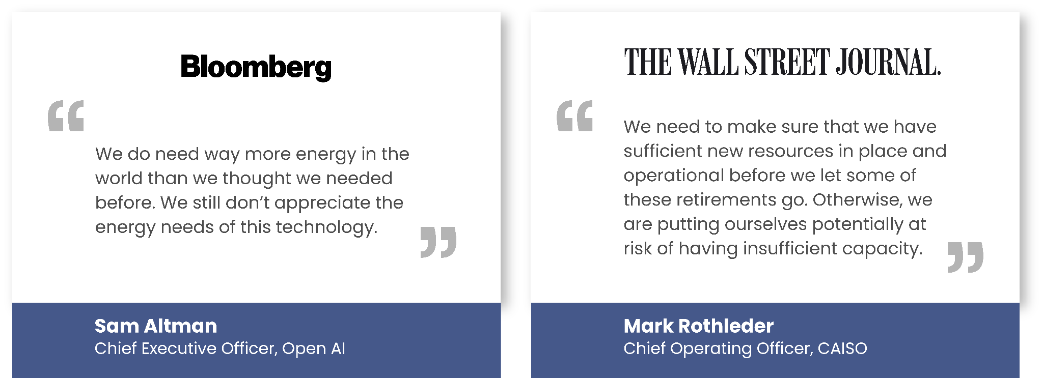

There are several salient near-term options that stakeholders can consider in meeting these power demand requirements at the transmission level, each with its own set of challenges from a sustainability, affordability, and reliability perspective. Three of these options are: (1) delaying the retirement of thermal generation plants (e.g., coal), (2) building additional new natural gas plants, and (3) building large-scale transmission to tie in new utility-scale renewable generation to the grid.

However, a fourth option also exists that is rarely evaluated but which can be an important solution for utilities: industrial load flexibility.

Within this, data centers specifically are one of the largest drivers of industrial demand growth. Historically, data centers have been built to draw continuous power from the grid and with under-utilized energy infrastructure (e.g., backup diesel generators that rarely run). With other energy technologies (e.g., battery energy storage) becoming increasingly cost-effective and reliable as a backup power source, and the ability to have flexibility in the dispatchability of certain AI workloads (e.g., large language training models), intelligently built and operated data centers can provide large-scale flexibility to the grid that can help utilities manage their peak-demand challenges. This approach has several benefits to utilities, such as improving resource adequacy using existing transmission and/or generation, managing peak demand more sustainably and affordably, and supporting offtake for curtailed and/or additional renewable energy generation resources.

The below sections walk through current data center practices today, how data centers can evolve to be more flexible, what benefits a flexible data center can provide, and how to begin unlocking this opportunity.

Status Quo Practices Have Overwhelmed the Grid

*Data centers are built today with backup diesel generators that are underutilized and dirty, and the industry’s massive growth has led to significant power constraints in core markets that will be exacerbated as demand continues to grow.*

A data center is a specialized warehouse that hosts IT infrastructure (i.e., servers), providing primarily two services: electricity, to provide continuous power to the servers, and cooling, in order to keep servers from overheating. Generally, the IT hardware is either owned by an enterprise that has an abundance of compute requirements and the sophistication to manage its own IT infrastructure, or a cloud services provider that manages IT infrastructure on behalf of other enterprises. The organizations that require the most compute needs, such as Amazon, Microsoft, Google, Meta, Apple and Oracle, are often referred to as “hyperscalers.”

*Figure B*

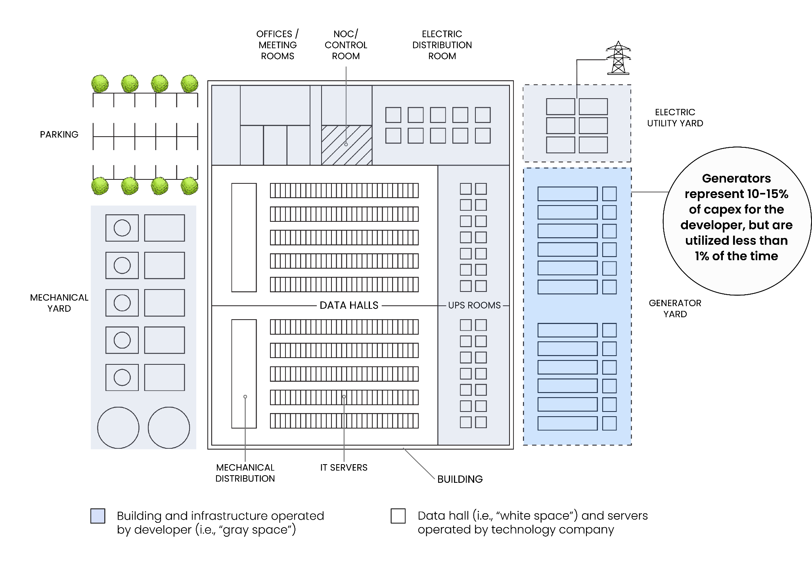

In an increasingly digital world, enterprises rely on and value uptime in order to continuously run their operations, which is why data centers have been historically built as depicted in Figure B. Locationally, facilities have been built in areas with strong grid stability and low natural disaster risk. Additionally, due to the benefits of clustering data centers around each other for technical reasons, a significant amount of capacity has aggregated around several core markets. This has been driven by factors such as the availability of a skilled labor force, a desire for low latency (the amount of time for data to travel to the end user), and data gravity (the efficiency in having large data sets and processes located close to each other).

To provide backup in the event there is a grid outage, data centers traditionally have been built with diesel generators and other mechanical equipment to run the data centers and servers during grid outages so that no loss of operations is experienced by the end user. However, since data centers are generally built in reliable locations, these diesel generators are rarely used.

Building data centers in geographic clusters was both preferred and acceptable when the scale of projects were in the tens of MWs each, and thus small relative to the local utility’s generation and transmission system. Now, forecasted data center projects are growing increasingly large in size, with the aggregate size requirements of certain campuses as large as hundreds of - or even more than a thousand - MWs for a planned development over a several year period. This represents the same amount of power required to energize hundreds of thousands of homes, but in a footprint as small as hundreds of acres. The result of this explosive demand growth is significant power constraints in core markets, often coupled with an abundance of underutilized diesel generator energy infrastructure. Areas across the country, from Northern Virginia to Silicon Valley and many in between, have had to put temporary pauses on new data center construction in order to more proactively plan and manage go-forward energy demand.

Continuing to build data centers with status quo practices will exacerbate the problem and lead to billions of dollars of inefficient capital expenditures in seldomly used diesel generators that additionally face increasing concerns from local communities regarding their environmental impacts.

**New Technology Enables a Different Approach to Data Centers**

*Advances in battery technology and the ability for certain AI workloads to be interruptible assets enable flexible use cases that can benefit the grid.*

It is highly unlikely that the demand for new data centers will decrease, and as a result there must be a more proactive approach to understanding how the next decade can support the corresponding energy infrastructure on the backdrop of the energy transition. Fortunately, advances in technology can enable a more bi-directional interactivity with the data center project and the utility that can allow the data center to be an asset to the grid. Broadly, this falls into two categories, as outlined below.

First is the actual data center energy infrastructure.

Simplistically, instead of building diesel generators for backup, other technologies can provide backup to the IT infrastructure and run in the event of grid outages. Today, lithium battery energy storage can provide sufficient backup to the IT infrastructure in certain locations relative to historical grid outage data, and can also provide grid services in peak demand periods. Battery technology has significantly declined in cost over the past several years, and prices are on pace to decline another 2x by 2035.[11] Battery prices are now comparable (on a $/watt basis) to diesel generators and could be even more cost competitive in the near future, without negative emissions implications. Utility scale batteries have proven effective in several markets in alleviating peak demand constraints, such as CAISO and PJM[12], and will continue to play an important role as many grid mixes shift towards more intermittent renewable generation sources. Furthermore, new technologies, such as other long-duration energy storage options and nuclear micro and small modular reactors, may be commercialized later this decade and could ultimately be able to serve longer-duration backup and grid support use cases. However, battery storage technology has not been widely adopted for data center use to-date.

Second is the underlying IT infrastructure, and the workloads that are run on the servers. Some workloads require continuous reliability in the form of uninterrupted power flows. However, significant portions of AI workloads do not have the same level of stringent requirements, and can be interrupted. AI itself can be broken up broadly into two types of compute.

The first type of AI compute is the “training” phase, during which a model is given a vast amount of information and patterns to learn. During training, the model analyzes data and adjusts its internal structure to make accurate predictions. This takes significant computational processing power, and thus energy. As an example of one such model, OpenAI’s GPT-3 required as much processing power as the 20 most powerful supercomputers combined,[13] with the training of its successor, GPT-4, costing over 100x that of GPT-3.[14] Separately, Google estimates that 40% of its AI energy use is driven by training.[15]

Once fully trained, a model enters the "inference" phase, where it uses its learned knowledge to analyze new, unseen data and make predictions based on what it has learned. Outputs from these models can be text, images (which can be 60x more energy intensive to generate than text),[16] and video (which will take even more energy to generate).[17]

As AI becomes more prevalent in a variety of day to day tasks - such as integration into search engines or communicating with AI agents[18] - and gains mass adoption across specific enterprise use cases, the number of models and thus communications across models will grow exponentially. The result will dramatically increase AI energy use, even in the near-term. One such estimate suggests that AI could use as much electricity as an entire small industrialized country by 2027[19].

However, training can be accomplished in a more flexible manner. The model owner could theoretically schedule the provisioning of power to run the training model in accordance with certain agreed upon planning windows with the utility in order to have it to be treated as a large-scale, flexible asset to the grid. This has many benefits and could significantly improve resource adequacy to the system in a more sustainable manner at a meaningful scale.

Harnessing both of these flexibility levers requires advances in the way that data centers are being built today from a design perspective, as well as a closer dialogue with customers on uptime requirements related to the underlying IT.

**This Approach Can Benefit the Utility**

*Data centers can be the connector that brings new energy infrastructure technologies to market throughout their development timelines in order to help utilities meet their IRP objectives.*

The flexibility of both the energy and IT infrastructure of a data center development is an asset that can be considered as part of a utility’s IRP. An IRP takes a multi-decade view on forecasted demand growth and generation mix, utilizing a bottoms-up build of potential loads to develop a model to meet economic, reliability, and sustainability objectives. Shorter-duration 4-6 hour lithium ion batteries are valuable assets today that are often included in these IRPs, but in some markets face hurdles in bringing to operations given a myriad of development and economic considerations. Further, as renewable penetration increases and the impact to utilities of short-duration battery energy storage declines as more storage assets are brought onto the grid (and therefore compete for dispatch in the same hours against each other), new technologies that are not yet proven at scale will be required in order to meet sustainability and resource requirements.

*Figure C*

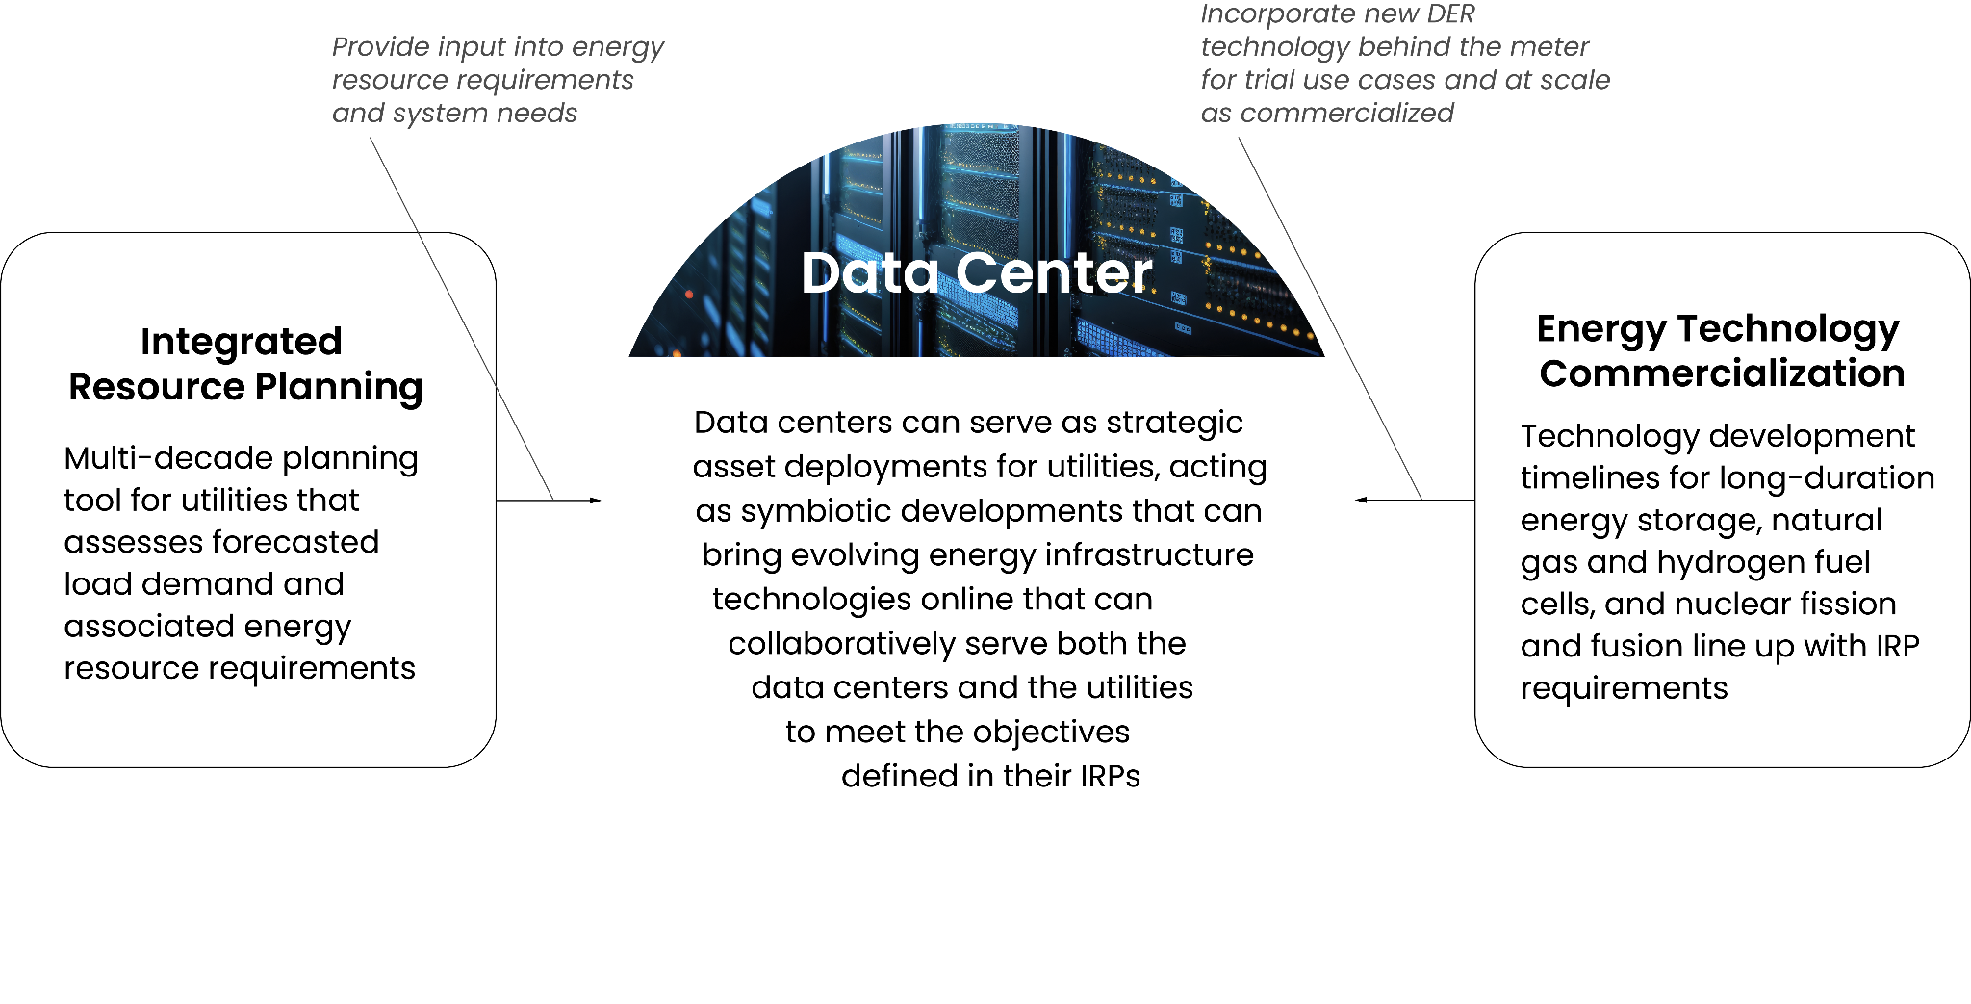

A phased data center development can be a pathway to incorporating valuable energy assets at scale into a utility’s IRP, by virtue of having an existing demand source (i.e., the data center) versus having to implement new market designs in order to achieve development of these assets on a standalone basis. A well-structured development plan can incorporate a myriad of assets “behind the meter” that can meet data center reliability requirements as well as provide value through a variety of grid services. Given the scale of these projects, the benefits can be substantial.

FIgure D shows a representative Load Duration Curve (“LDC”) for a typical utility, plotting the electricity load for every hour of the year from peak demand to lowest demand. The figures included in this section are based on actual data from a utility that are rounded to both anonymize the utility and also to simplify the example.

The LDC is a critical analytical tool that ultimately drives infrastructure and resource decisions for utilities. In recent years, as the economy has continued to electrify, central station intermittent renewables have been added, and the nation has experienced more extreme weather events, LDCs have become increasingly “peakier,” meaning the far-left hand side of the LDC has increased upwards (versus a flatter LDC across the hours of a year). To accommodate these peak demand events, utilities have had to delay the retirements of or build new fossil based peaker plants, as well as build additional transmission. This has resulted in a significant underutilization of infrastructure throughout significant parts of the year, increasing the overall system cost to both utilities and ratepayers.

*Figure D*

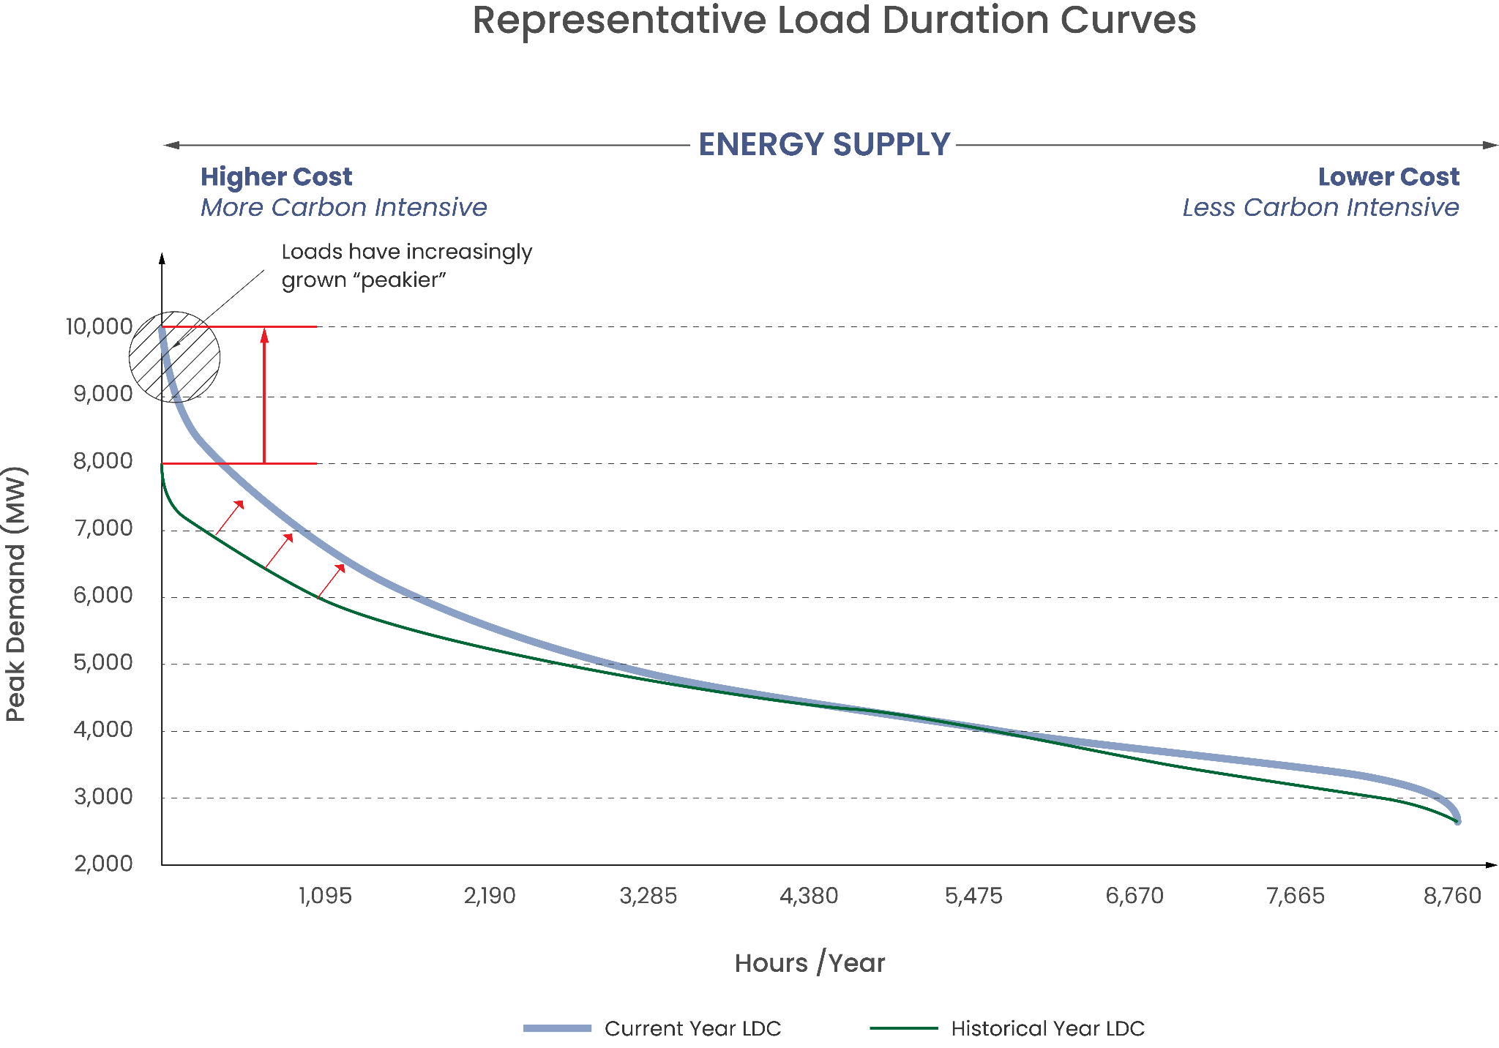

Understanding the LDCs at a more granular level can help better inform utilities’ constraints that they are attempting to solve for in their IRPs. As mentioned above, many of these constraints occur in solving for the peak demand hours. Absent flexibility, these investment decisions to accommodate the peak hours will often include overbuilding transmission and/or relying on fossil based peaker plants.

For example, as shown in Figure E, which is likewise representative for many utilities, the utility only exceeds 96% of its peak load 11 hours (0.1% of the year), with the maximum continuous hours over that peak being 4 hours. This means that this peak load in excess of 9,600 MWs could be solved with large-scale 4 hour battery energy storage. Further, the utility only exceeds 90% of its peak load for 89 hours (1% of the year), with the maximum continuous hours over that peak being 8 hours.

*Figure E*

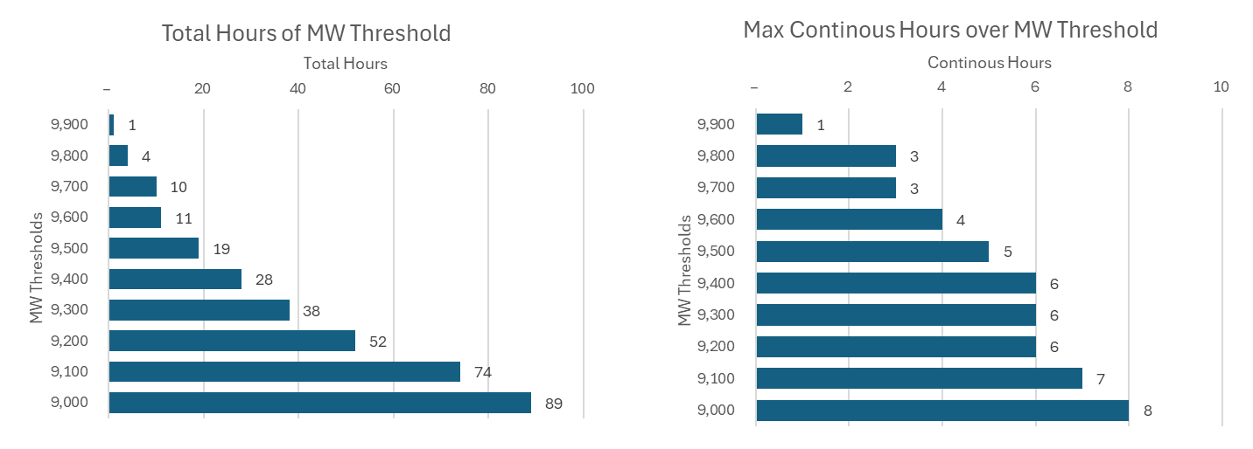

Incorporating a data center project with flexibility has the potential to have a dramatic impact in the ability for utilities to help manage their peak demand. In the example below, the utility is assumed to be managing a data center queue of 1,000 MWs. In Figure F, the “Status Quo Scenario” assumes that the data centers are brought online with no flexibility, thus increasing peak demand requirements by 1,000 MWs, or 10% of existing peak load. The same peaking profile will remain as described above, and additional generation and transmission will be required to support the load.

The “Flexible Scenario” incorporates both energy infrastructure (specifically battery energy storage) and IT flexibility to better utilize existing utility infrastructure and help manage peak issues. On the latter, the data centers can work collaboratively with the utility to define certain periods of the year where training workloads and their mechanical loads can be flexible for prescriptive periods of time during significantly constrained periods. Given that certain workloads are not constrained by the same time limitations as batteries, it could be a valuable resource in helping solve for longer-duration flexibility needs. For example, by requiring power for 99% of the year (instead of 99.999%), flexible IT could help solve for the 89 hours (the 1% of the year) when the system is over 90% peak capacity and would otherwise need a resource up to 8 continuous hours.

Relative to adding 1,000 MWs in the “Status Quo Scenario,” the “Flexible Scenario” peak demand would only increase modestly relative to the Representative Utility LDC or could even *decrease* depending on the amount of flexibility offered to the utility across the energy infrastructure and IT.

*Figure F*

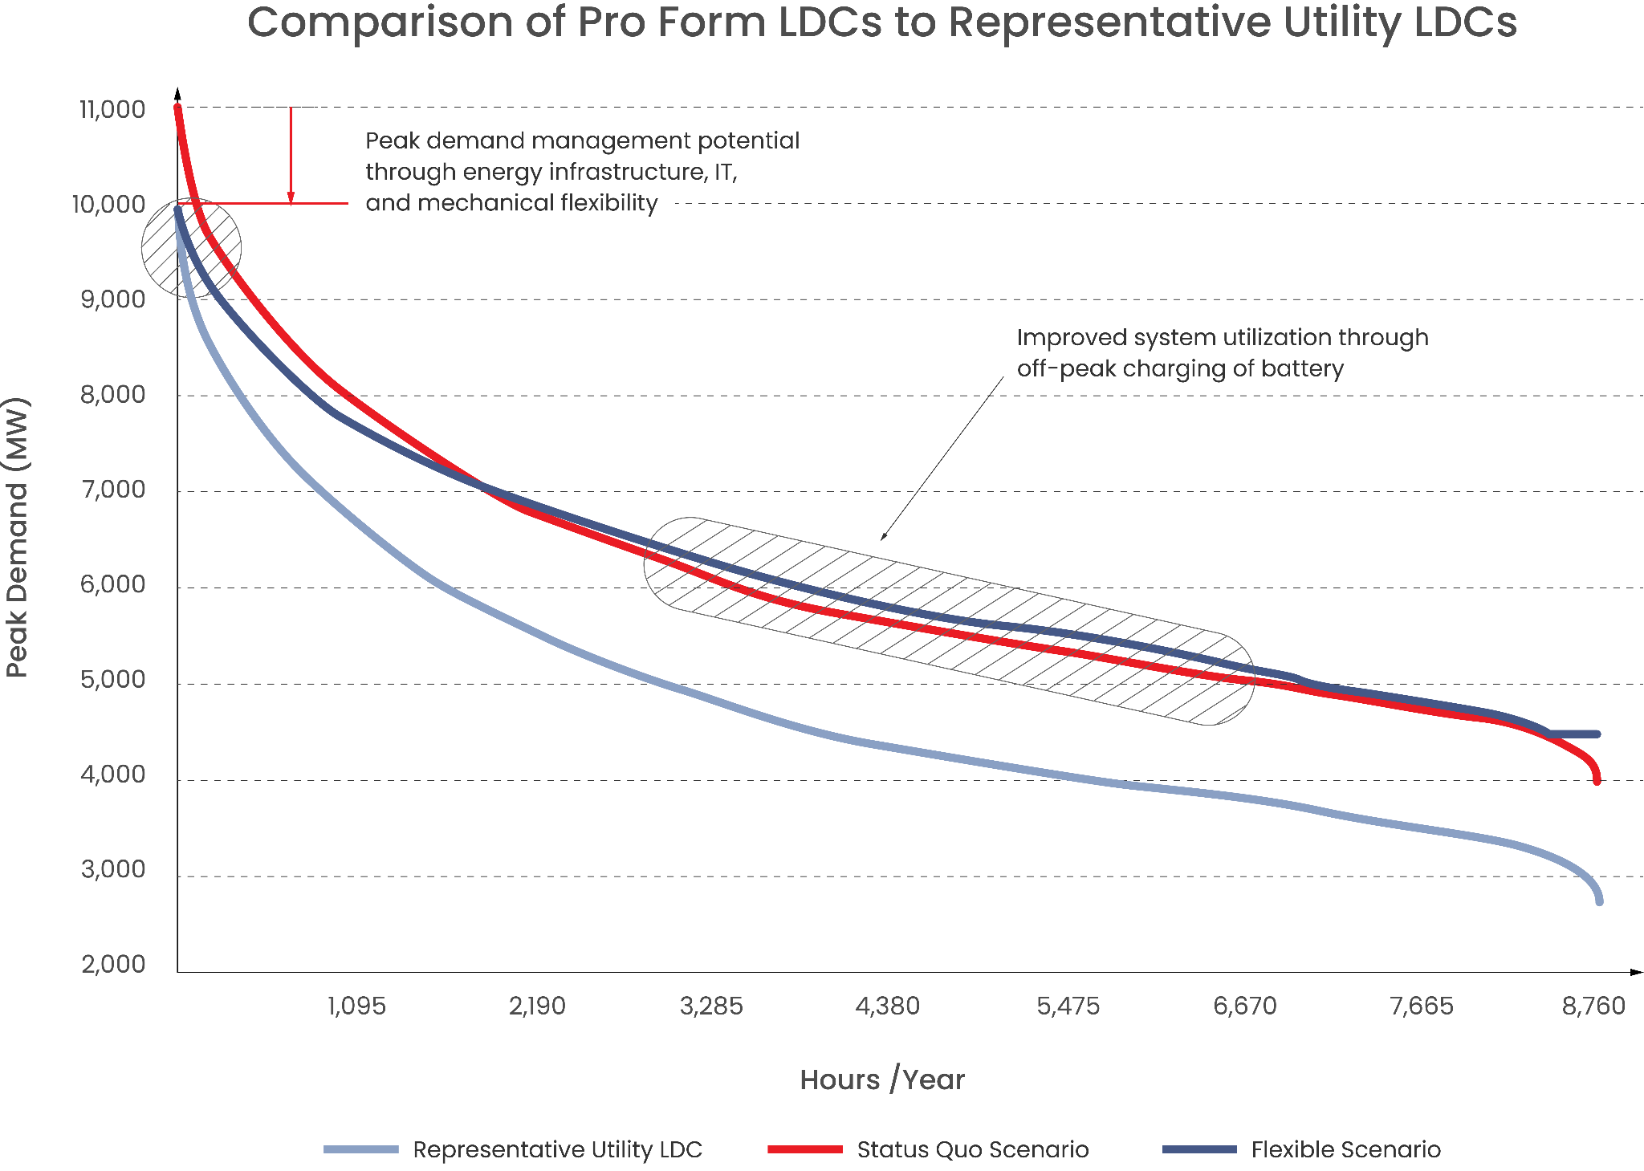

In this example, the utility would be able to leverage a myriad of flexibility tools to help alleviate certain constraints, and importantly, the load factor (the utilization of the energy infrastructure) would increase by over 10%, driving additional benefits for the utility. Note that this analysis does not assume the data center incorporates emerging technologies (e.g., other long-duration energy storage) over time throughout the data center’s development and lifecycle, which could further improve its capabilities and usefulness for grid services.

While the specific impacts will vary based on the utility’s infrastructure and generation mix, the benefits include more affordable peak demand management, increased system utilization, and thus a more sustainable and cost effective grid for all energy consumers.

**This Requires a New Approach to Interconnection**

*Data centers, utilities, grid operators, and policymakers must collaborate in order to understand, plan, and ultimately deploy projects that benefit utilities and their stakeholders.*

Historically, data center interconnections have been a “one-way” process whereby developers request access to power, and the utility works on power studies to arrive at a feasible power solution and associated timeline. This was acceptable in an era with abundant power resources and when data center capacity was not being implemented at the scale it is today. However, in the face of the increasing peak supply-demand imbalance and go-forward scale of new interconnection requests for a multitude of large-scale industrial use cases (including but not limited to data centers), it is no longer feasible and is resulting in significantly delayed timelines, or outright denial, for new projects

Moving forward, a more collaborative approach to planning can serve as a “win-win” for both data center developments and the utilities, by enabling access to power for a project in exchange for that project providing valuable grid services to help the utility manage against its constraints. As outlined above, many of these issues are solvable with flexibility and collaboration.

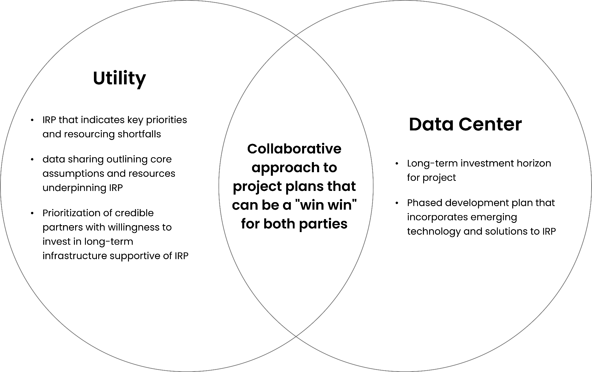

With each utility facing different challenges, it is important that both the utility and data center developer align upfront on a project development plan and opportunity, and then work collaboratively to translate the plan into defined utility-facing products that ultimately can be included in the IRP. These products will take into account the various resources (i.e., the energy infrastructure and IT flexibility) in the near-, medium-, and long-term. Alongside these planning efforts, both parties should work constructively with policymakers to establish standards, create the proper incentives, and define interconnection processes in order to achieve desired load flexibility outcomes over time.

Additionally, as utilities plan for a multitude of interconnection requests, it is important that the utility and developer align upfront on siting characteristics such that large-scale infrastructure planning can be synergistic with development, particularly as the utility balances the buildout of other electrification initiatives (e.g., commercial charging depots).

Starting with a utility-first lens to solving energy challenges will enable a clearer set of goals for the data center with respect to flexibility requirements, which will allow a collaborative approach that will break through the current backlog of projects by enabling access to power.

**Conclusion and Recommendations**

To summarize, data center projects can (1) provide operational flexibility to meet both customer compute demand and grid service needs, and (2) serve as strategic asset deployments for utilities, acting as symbiotic developments that can bring evolving energy infrastructure technologies online that can collaboratively serve both the data centers and the utilities to meet the objectives defined in their IRPs.

In order to best maximize the value of these benefits and enable access to power to build critical domestic infrastructure, it is imperative that all parties - data centers, utilities, grid operators, and policymakers - collaborate to understand the value data centers can bring. Clearly identifying specific utility constraints, and understanding how data center flexibility can enable grid services will allow more effective access to power in a way that is beneficial for all parties and that provides significant cost-savings for energy consumers.

To realize the benefits of data center flexibility, the Data Center Flexibility Initiative invites interested stakeholders to provide feedback so that we can collectively begin to take action, starting with the below suggested next steps:

1. Creating channels to convene a diverse set of stakeholders - such as utilities, policy makers, and/or hyperscalers - through events, working groups, and other exchanges of information to brainstorm and ultimately implement flexibility initiatives;
2. Commissioning research on the potential grid impact, such as through partnerships with universities, national labs, and other researchers;
3. Ensuring that potential federal funders, including the Advanced Research Projects Agency–Energy (ARPA-E), the Loan Programs Office (LPO) and other US Department of Energy programs, are aware of the benefits of data center flexibility;
4. Obtaining private sector commitments to invest capital into more flexible data center projects;
5. Implementing pilot projects and creating case studies on their results for dissemination across utilities, policymakers, and other key stakeholders.

It is a challenging, and exciting, time in our country’s history. With the rapid technology advancements and increased capabilities that onshoring manufacturing provides, we are poised to take another significant step forward in innovation and leadership in the global marketplace. However, if we do not solve the power constraint problem, we will fall behind, instead of moving ahead, in this evolution. We look forward to engaging with stakeholders in this critical initiative.

1. The Economist; [Data centres improved greatly in energy efficiency as they grew massively larger; But can this continue into the age of AI?](https://www.economist.com/technology-quarterly/2024/01/29/data-centres-improved-greatly-in-energy-efficiency-as-they-grew-massively-larger)
2. McKinsey; [The Net Zero Transition: What it could cost, what it could bring](https://www.mckinsey.com/~/media/mckinsey/business%20functions/sustainability/our%20insights/the%20net%20zero%20transition%20what%20it%20would%20cost%20what%20it%20could%20bring/the-net-zero-transition-what-it-would-cost-and-what-it-could-bring-final.pdf)
3. BNEF; New Energy Outlook 2022
4. The Economist; [Data centres improved greatly in energy efficiency as they grew massively larger; But can this continue into the age of AI?](https://www.economist.com/technology-quarterly/2024/01/29/data-centres-improved-greatly-in-energy-efficiency-as-they-grew-massively-larger)
5. Boston Consulting Group; The Impact of GenAI on Electricity
6. Bloomberg; [AI Needs So Much Power That Old Coal Plants Are Sticking Around](https://www.bloomberg.com/news/articles/2024-01-25/ai-needs-so-much-power-that-old-coal-plants-are-sticking-around)
7. NCSL; [State Policies Promoting Hybrid and Electric Vehicles](https://www.ncsl.org/energy/state-policies-promoting-hybrid-and-electric-vehicles#Body)
8. IRS; [Credits for new clean vehicles purchased in 2023 or after](https://www.irs.gov/credits-deductions/credits-for-new-clean-vehicles-purchased-in-2023-or-after)
9. Federal Register; [Executive Order 14037](https://www.federalregister.gov/documents/2021/08/10/2021-17121/strengthening-american-leadership-in-clean-cars-and-trucks): Strengthening American Leadership in Clean Cars and Trucks
10. BloombergNEF; Electric Vehicles Long-Term Outlook
11. BNEF; 2023 Lithium-Ion Battery Price Survey
12. WSJ; [Giant Batteries Helped the U.S. Power Grid Eke Through Summer](https://www.wsj.com/business/energy-oil/giant-batteries-helped-the-u-s-power-grid-eke-through-summer-a68425fd?cx_testId=3&cx_testVariant=cx_170&cx_artPos=4&mod=WTRN#cxrecs_s)
13. Forbes; [Artificial Intelligence Electricity Use Is In The Crosshairs](https://www.forbes.com/sites/jamesbroughel/2024/01/10/artificial-intelligence-electricity-use-is-in-the-crosshairs/?sh=3392944e44fb)
14. Data Center Dynamics; [Generative AI & the future of data centers: Part I - The Models](https://www.datacenterdynamics.com/en/analysis/generative-ai-hype-opportunity-and-the-future-of-data-centers-part-i/)
15. Columbia Climate School; [AI’s Growing Carbon Footprint](https://news.climate.columbia.edu/2023/06/09/ais-growing-carbon-footprint/)
16. Luccioni,, Jernite, Strubell; Power Hungry Processing: Watts Driving the Cost of AI Deployment?
17. Wired; [OpenAI’s Sora Turns AI Prompts Into Photorealistic Videos](https://www.wired.com/story/openai-sora-generative-ai-video/)
18. Forbes; [AI Agents And The Era Of The Intelligent Interface](https://www.forbes.com/sites/davidarmano/2023/12/07/ai-agents-and-the-era-of-the-intelligent-interface/?sh=41b6c8f565b4)
19. New York Times; [A.I. Could Soon Need as Much Electricity as an Entire Country](https://www.nytimes.com/2023/10/10/climate/ai-could-soon-need-as-much-electricity-as-an-entire-country.html)